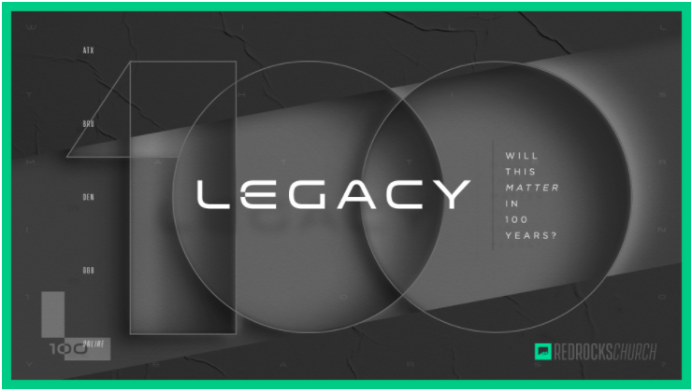

Where Legacies Are Born | Ronnie Johnson | 1.17.21
Weekly Study

START

To get things started, go around the circle and answer the following question:

How are your New Year’s Resolutions going? Did you set any? Have you kept any?

SHARE

Welcome to Week Two of our new series, Legacy! For the next several weeks, we will be talking about what it looks like to live a life that is bigger than ourselves. This week, Ronnie talked about how daunting it can feel to try to leave a legacy. But before we dive in, take some time to catch up with your Group by answering the following questions.

What is one word you would use to describe how you are currently feeling? Why did you choose that word?

What is one thing you are looking forward to in 2021?

What do you feel like God is teaching you right now?

GRow

Read John 5:1-15

What stuck out to you about this passage? Why?

What does this story teach us about Jesus?

When you read that story, did you relate more with Jesus or the man on the mat? Why?

Building a legacy can be daunting, but as Ronnie reminded us this weekend, the process for leaving a legacy is actually very simple—you just have to be willing to say YES! However, simple doesn’t always mean easy.

In the passage you just read, the man on the mat struggled to say yes. We don’t know much about the man in this story, but we do know that he has been sitting on his mat for 38 years, waiting for someone to carry him into the water so that he can heal. That’s a long time to be hurt. Obviously, whatever he has been trying is not working. But fortunately for him, healing, restoring, and redeeming is what Jesus does best. Jesus walks right up to this man and asks him a personal but profound and question. Do you want to be well?

On the surface, that feels like an obvious question with an easy answer. Who wouldn't say YES to that? But deciding to get healthy is often more complicated than we think.

What if we can finally walk, but we fall?
What if we finally get that job, but we get fired?
What if we finally find that community, but then we get hurt?

Life can be filled with trepidation. And so, when Jesus asks if we want to be healthy, the answer may not be as black and white as we often think. Like us, this man needs to change the way he thinks about God and the way He brings healing to the world. Or, as Paul writes to the church in Rome, he needs to be "transformed by the renewing of his mind" (Romans 12:2).

As Ronnie reminded us this weekend, “we like the idea of God changing our circumstances more than we like the idea of God changing us.” But the truth is, God is always ready to heal, redeem, and restore; we just need to be willing to change and then start saying YES! Take some time to talk to each other about what that looks like in your own life by answering the following questions.

What is one of your proverbial “mats” that you find yourself hanging onto in life? Do you want to be healed?

Do you feel like you are leaving a legacy of “yes”? Why or why not?

M O V E

Read Hebrews 11:1-13

What stuck out to you about this passage? Why?

What does this passage teach us about Jesus?

All legacies start with someone saying YES to God. It's easy to read stories about the heroes of the faith and feel like they somehow had a superpower that we don't have, but that isn't true.

Sometimes we feel like the mistakes we've made in the past disqualify us from leaving a legacy, but nothing could be further from the truth. When we read about the great men and women in the Bible, we are reminded that they were broken people just like us. The difference is, they made a deep resolve with themselves to trust God in a way that others could not. The list is full of murderers, adulterers, and outcasts who all had radical, personal encounters with God and decided that they were tired of trying to do life their way. They put their trust in God, and the rest is history!

We have the same opportunity to reach a world that is desperately hurting. No matter what your past looks like, you can make the decision, right now, to say YES to God with your future!

How do you want to be remembered? What is the legacy you want to leave on this planet?

What is one practical and tangible step you can take today to begin saying YES to the legacy you want to leave?

P R A Y

As a group, spend some time praying with and for each other. If you are in a coed group, consider breaking up into men's and women's groups to share more freely.

T O G O

Now faith is confidence in what we hope for and assurance about what we do not see.
– Hebrews 11:1

