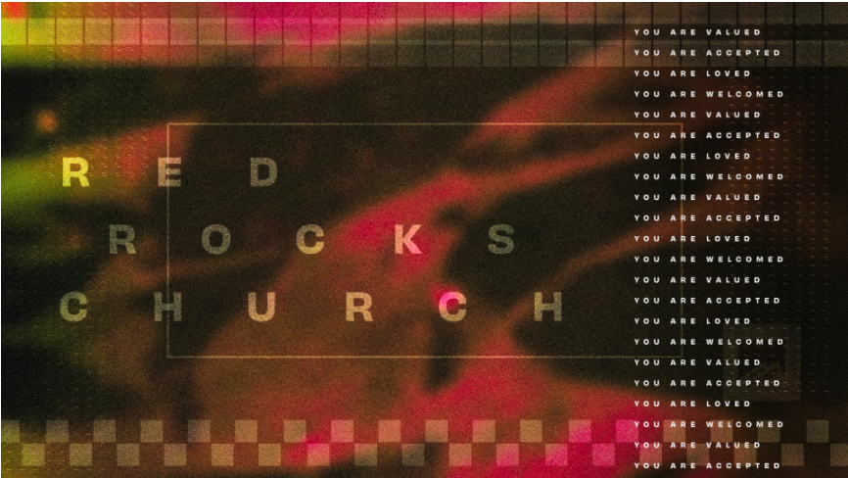

Kill the Scoreboard | Ronnie Johnson | 4.11.21
Weekly Study

S T A R T

To get things started, go around the circle and answer the following question:

What is your favorite part about the Spring?

S H A R E

Welcome back to Group! This week, Ronnie gave a message about the power of grace in our lives. Before we dive into the sermon, take some time to check in with your Group by answering these questions.

What is one word you would use to describe how you are currently feeling? Why did you pick that word?

What was the most challenging part of your week?

What was the highlight of your week?

What is one thing on your mind that is keeping you from being present in this moment?

G R O W

Read Romans 5:12-21

What verse stuck out to you the most in this passage? Why?
What do you know about Romans? Who is writing, and who are they writing to?

The Apostle Paul wrote nearly half the books of the New Testament. He was a traveling church planter, who went into new cities, started churches, raised leaders, and then left and repeated the process. Later on, he would write them letters to continue to instruct and inform them. However, when Paul wrote the letter to the Romans, he hadn't been there yet. Lots of scholars believe Romans is longer and more detailed because he didn't have time to explain the Gospel in person.

That’s why Romans is such a gift for the church today. It reminds us who we are, who Jesus is, and what he did for us on the cross. We have all sinned and fallen short of the original plan God set out for us. Since humans are prone to wander from the path, God gave us the law to provide some guardrails. But it didn't work. Humans continued to rebel. As Paul wrote in the passage you just read, "The law was brought in so that the trespass might increase. But where sin increased, grace increased all the more” (Romans 5:20).

This is the beauty of the cross. As Ronnie reminded us this week, if the law is our scoreboard, we aren’t going to like the results. Fortunately, Jesus came to do away with the scoreboard. As Paul later wrote, “For Christ is the end of the law for righteousness to everyone who believes” (Romans 10:4).

As followers of Jesus, we get to ditch the scoreboard because we know that Jesus has already made a way for us to have right standing with God!

No matter how many times you’ve heard the Gospel, it never stops transforming your life. What stuck out to you from studying the book of Romans this week?

What is one way you are still trying to keep score with your behavior? Why do you think you do that?

M O V E

Read Romans 8:1-11

What do you think it means that there is now no condemnation for those in Christ Jesus (Romans 8:1)?

How does this passage help you kill your scoreboard?

Romans 8 is one of the most powerful chapters in the Bible! In the passage you read, Paul reminds us: And if the Spirit of him who raised Jesus from the dead is living in you, he who raised Christ from the dead will also give life to your mortal bodies because of his Spirit who lives in you.

The same Spirit that raised Jesus is alive and living in you! Think about that for a second. As Christians, we often walk around defeated, feeling like since we are losing on the scoreboard, we will never amount to anything. We feel like we are too far behind, so we will never be able to break that addiction, get that promotion, or beat that illness. But the Gospel changes everything! The truth is, the Spirit of the living God is living inside of you! Because of what Jesus did for us, it is time for a new mindset.

As Ronnie reminded us this week, “If you kill your scoreboard and let grace keep the score, God will begin doing things in your life that will blow you away.” Jesus has already done away with the scoreboard. Now, grace keeps the score!

Do you truly believe that grace keeps the score in your life? Are you currently living as if that is true?

P R A Y

We need prayer now more than ever. Spend some time-sharing prayer requests. If you are in a coed group, consider breaking off into two separate groups (or calls if you are an online group) to share more freely.

T O G O

For since the creation of the world God’s invisible qualities—his eternal power and divine nature—have been clearly seen, being understood from what has been made, so that people are without excuse.
- Romans 1:20

